STEP:1 CREATE MAVEN QUICK START APP

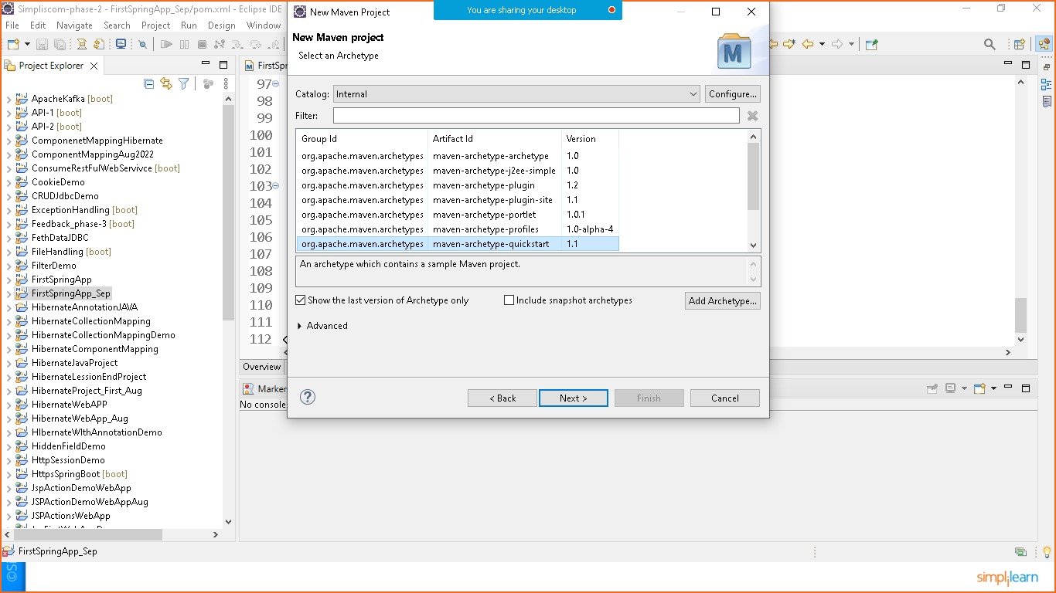

Give Group id package Id and Name

Click on finish

STEP:2 Add dependenciesTo **pom.xml** file

1. Spring context
2. Spring core
3. Spring beans

**Pom.xml**

<project xmlns="http://maven.apache.org/POM/4.0.0" xmlns:xsi="http://www.w3.org/2001/XMLSchema-instance" xsi:schemaLocation="http://maven.apache.org/POM/4.0.0 http://maven.apache.org/xsd/maven-4.0.0.xsd">

<modelVersion>4.0.0</modelVersion>

<groupId>com.simplilearn.demo</groupId>

<artifactId>FirstSpringApp_Sept</artifactId>

<version>0.0.1-SNAPSHOT</version>

<packaging>jar</packaging>

<name>FirstSpringApp_Sept</name>

<url>http://maven.apache.org</url>

<properties>

<project.build.sourceEncoding>UTF-8</project.build.sourceEncoding>

</properties>

<dependencies>

<dependency>

<groupId>junit</groupId>

<artifactId>junit</artifactId>

<version>3.8.1</version>

<scope>test</scope>

</dependency>

<!--Spring core-->

<dependency>

<groupId>org.springframework</groupId>

<artifactId>spring-core</artifactId>

<version>5.3.22</version>

</dependency>

<!--Spring Beans-->

<dependency>

<groupId>org.springframework</groupId>

<artifactId>spring-beans</artifactId>

<version>5.3.22</version>

</dependency>

<!--Spring Context-->

<dependency>

<groupId>org.springframework</groupId>

<artifactId>spring-context</artifactId>

<version>5.3.22</version>

</dependency>

</dependencies>

</project>

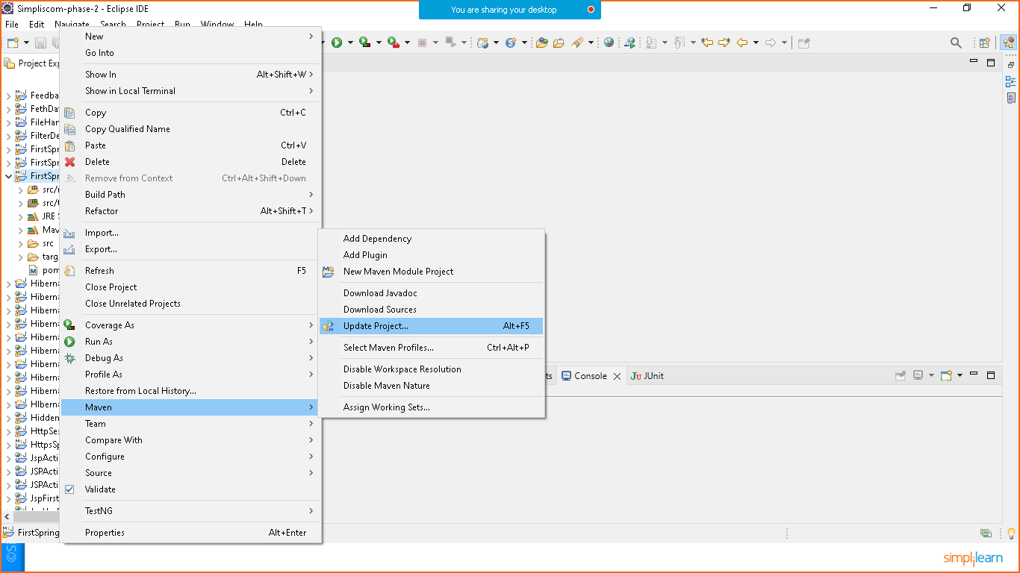

STEP:3 CRAETE JAVA CLASS

**HelloWorld.java**

**package** com.simplilearn.demo;

**public** **class** HelloWorld {

**public** **void** print() {

System.***out***.println("Welcome to Spring Framework");

}

}

Create Resource Folder

Right click on project > resource folder>prepare **beans.xml** file

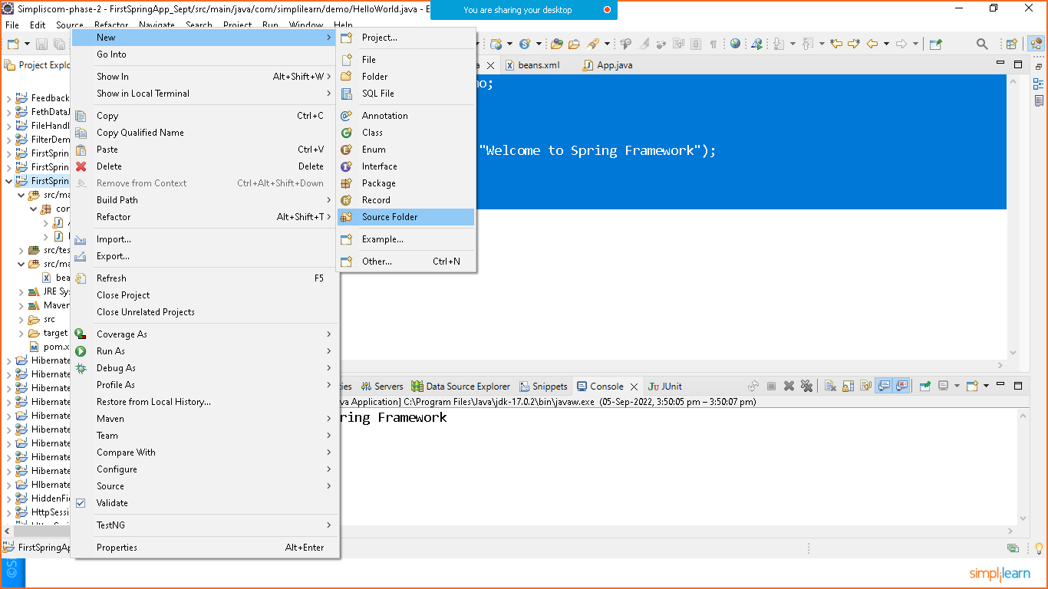

Goto to google and search for **spring beans xsd** file

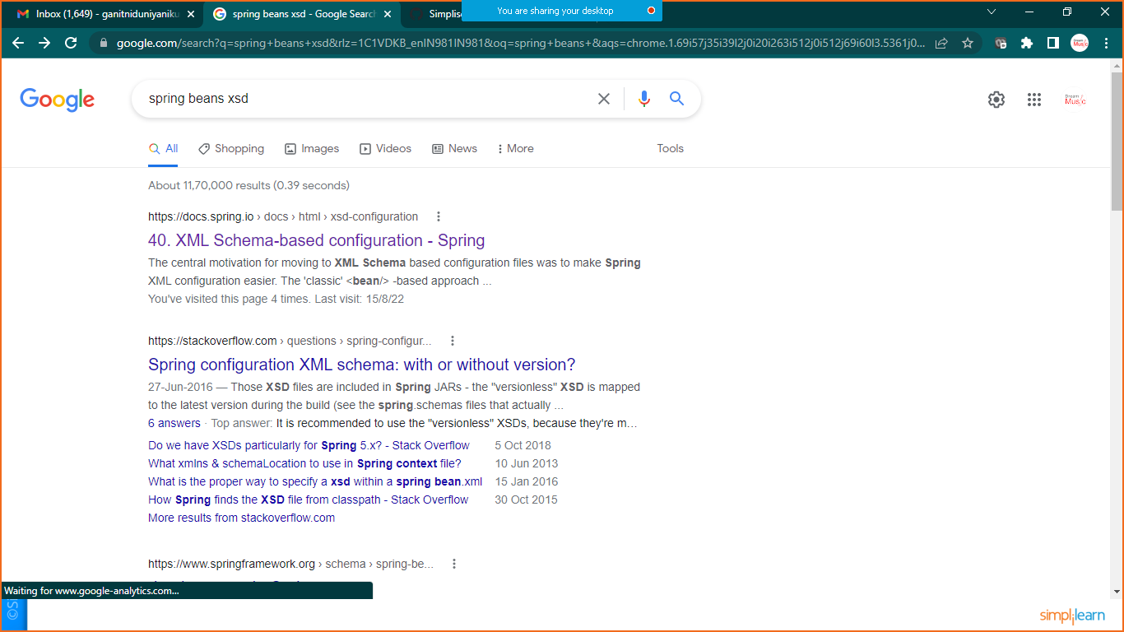

Choose first link

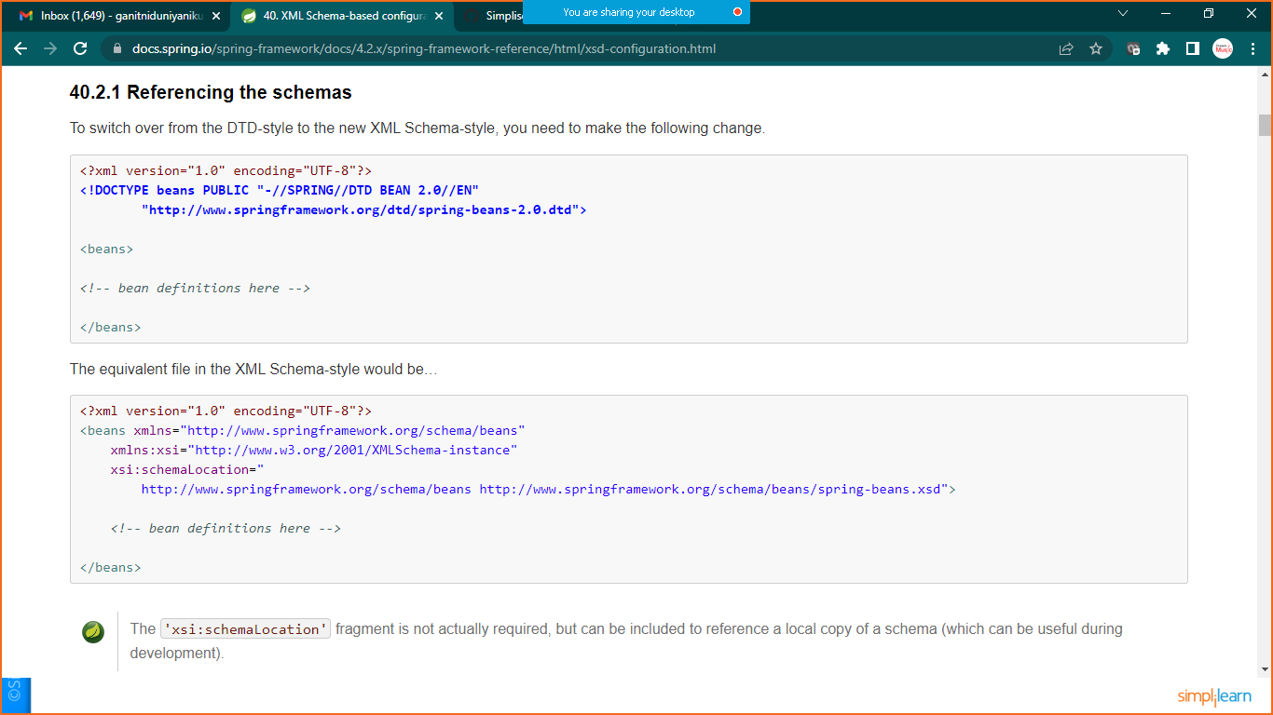

Copy xsd schema to **beans .xml** file

**Link:** **https://docs.spring.io/spring-framework/docs/4.2.x/spring-framework-reference/html/xsd-configuration.html**

**Beans.xml**

<?xml version=*"1.0"* encoding=*"UTF-8"*?>

<beans xmlns=*"http://www.springframework.org/schema/beans"*

xmlns:xsi=*"http://www.w3.org/2001/XMLSchema-instance"*

xsi:schemaLocation=*"*

*http://www.springframework.org/schema/beans http://www.springframework.org/schema/beans/spring-beans.xsd"*>

<!-- bean definitions here -->

<bean id=*"obj"* class=*"com.simplilearn.demo.HelloWorld"*></bean>

</beans>

Now goto the App.java

**package** com.simplilearn.demo;

**import** org.springframework.beans.factory.BeanFactory;

**import** org.springframework.beans.factory.xml.~~XmlBeanFactory~~;

**import** org.springframework.context.ApplicationContext;

**import** org.springframework.context.support.ClassPathXmlApplicationContext;

**public** **class** App

{

**public** **static** **void** main( String[] args )

{

//BeanFactory factory=new XmlBeanFactory(resources);

ApplicationContext context= **new** ClassPathXmlApplicationContext("beans.xml");

HelloWorld h= (HelloWorld)context.getBean("obj");

h.print();

//System.out.println( "Hello World!" );

}

}

Right click on project and run as java application

